Assignment-Chapter 7&8 (100 points)

Student Name: Hannah Roach ID: 678363897

1. Please write down two ways to set the range of an axis in a plot. (4 points)

You can use xlim() or ylim() to set the minimum and maximum values of a continuous axis.

For example, ylim(0,10).

You could also use scale_x_continuous() or scale_y_continuous(). For example, scale_y_continuous(limits=c(0,10))

1. Use the mtcars data frame to draw four graphs, respectively. Write down the used functions in ggplot2 (30 points)

(a)

install.packages(c("ggplot2","gcookbook"))

library(ggplot2)

library(gcookbook)

p <- ggplot(mtcars, aes(x=wt, y=mpg)) + geom_point()

p + annotate("text", x=4, y=25, label = "Some text", size = 6)

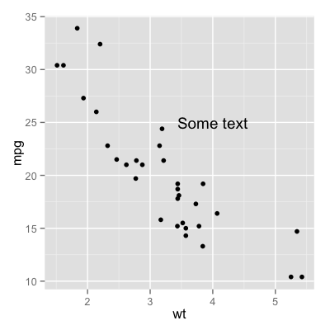

(b)

xvalues <- data.frame(2:5)

flabels <- data.frame(drv = xvalues, label = c("Some text","Some text","Some text","Some text"))

p <- ggplot(mtcars, aes(x=wt, y=mpg)) + geom_point()

p + annotate("text", x = c(2,3,4,5), y = 25, label = "Some text", size =6)

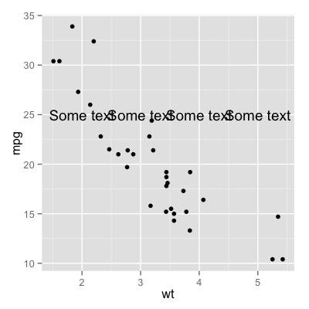

(c)

p <- ggplot(mtcars, aes(x=wt, y=mpg)) + geom_point()

p + annotate("rect", xmin = 3, xmax = 4.12, ymin = 11.5, ymax = 21.25, alpha = .2 )

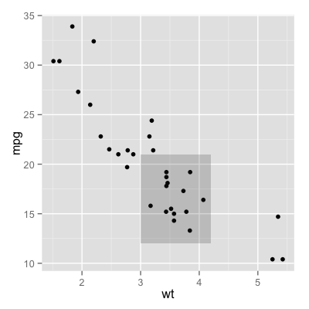

(d)

p <- ggplot(mtcars, aes(x=wt, y=mpg)) + geom_point()

p + annotate("segment", x = 2.5, xend = 4 , y = 15, yend = 25, colour = "blue")

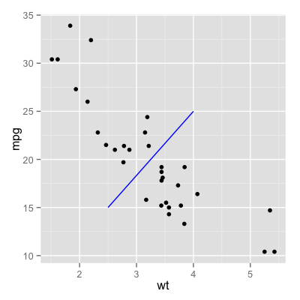

(e)

p <- ggplot(mtcars, aes(x=wt, y=mpg)) + geom_point()

p + annotate("text", x=1.9, y=20, label = "my label", size = 6) +

annotate("text", x=3, y=21, label = "label 2", size = 6)

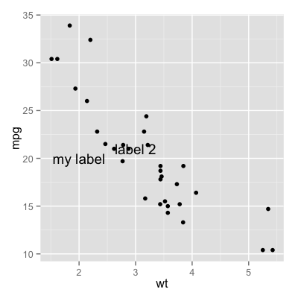

1. Use data frame PlantGrowth and write functions to draw graphs, respectively. (30 points)

(a)

ggplot(PlantGrowth, aes(x = group, y = weight)) + geom_boxplot()

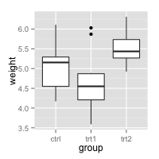

(b)

ggplot(PlantGrowth, aes(x = group, y = weight)) + geom_boxplot() + coord_flip()

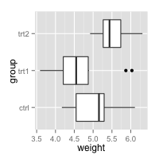

(c)

ggplot(PlantGrowth, aes(x = group, y = weight)) + geom_boxplot() +

scale_x_discrete(limits=c("trt1", "trt2", "ctrl"))

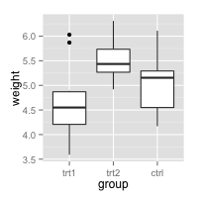

(d)

ggplot(PlantGrowth, aes(x = group, y = weight)) + geom_boxplot() +

scale_x_discrete(limits=c("trt2", "trt1", "ctrl"))

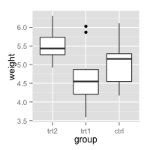

1. Following the same data frame in question 2, and use and write functions to draw the following graphs, respectively. (18 points)

(a)

ggplot(PlantGrowth, aes(x = group, y = weight)) + geom_boxplot() +

scale_x_discrete(breaks=c("ctrl","trt1", "trt2"),

labels=c("Control","Treat1","Treat2"))

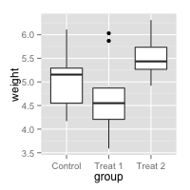

(b)

ggplot(PlantGrowth, aes(x = group, y = weight)) + geom_boxplot() +

theme(axis.ticks = element_blank(), axis.text.x = element_blank()) +

scale_x_discrete(breaks=NULL)

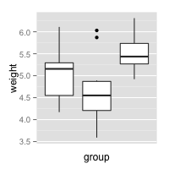

(c)

ggplot(PlantGrowth, aes(x = group, y = weight)) + geom_boxplot() +

theme(axis.ticks = element_blank(), axis.text.x = element_blank())

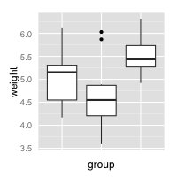

1. Following the same data frame in question 2, and use and write functions to draw the following graphs, respectively. (18 points)

(a)

ggplot(PlantGrowth, aes(x = group, y = weight)) + geom_boxplot() +

scale_x_discrete(limits=c("ctrl", "trt1", "trt2")) +

theme(axis.title.x = element_blank()) +

ylab("Weight(kg)")

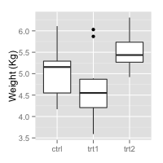

(b)

ggplot(PlantGrowth, aes(x = group, y = weight)) + geom_boxplot() +

scale_x_discrete(limits=c("ctrl", "trt1", "trt2")) +

ylab("Weight(kg)") + xlab("")

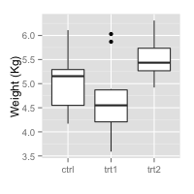

(c) You can use any size and color for the text.

ggplot(PlantGrowth, aes(x = group, y = weight)) + geom_boxplot() +

scale_x_discrete(limits=c("ctrl", "trt1", "trt2")) +

ylab("Weight(kg)") +

theme(axis.text.x = element_text(color = "gray", size = rel(2), angle = 90)) +

theme(axis.title.x = element_text(color = "red", size = rel(3)))

